# The Lead and Copper Rule

The purpose of the lead and copper rule is to protect public health by minimizing lead and copper levels in drinking water. Because lead and copper in drinking water is mainly due to the corrosion of service lines and household plumbing, tap water samples are collected at kitchen or bathroom taps of residence and other buildings. Public health benefits include;

* Reduction in risk of lead exposure, which can cause damage to the brain, red blood cells and kidneys, especially for young children.
* Reduction in risk of copper exposure, which can cause stomach and intestinal distress, liver and kidney damage.

## Monitoring Requirements

The number of required samples and frequency of monitoring is based on the population served by the water system, and its most recent rounds of lead and copper sample results.

Check waterLink to see when your water system is scheduled to conduct sampling. If you are on reduced monitoring (sampling yearly or once every 3 years), then your lead and copper **samples are required to be collected in the June 1 through September 30th** time frame.



## Sample Site Plans

Systems are required to have a lead and copper samples site plant to identify residences and other locations most likely to have high levels of lead and/or copper.

* Sample Site Plan Full Packet
* Sample Site Plan Form

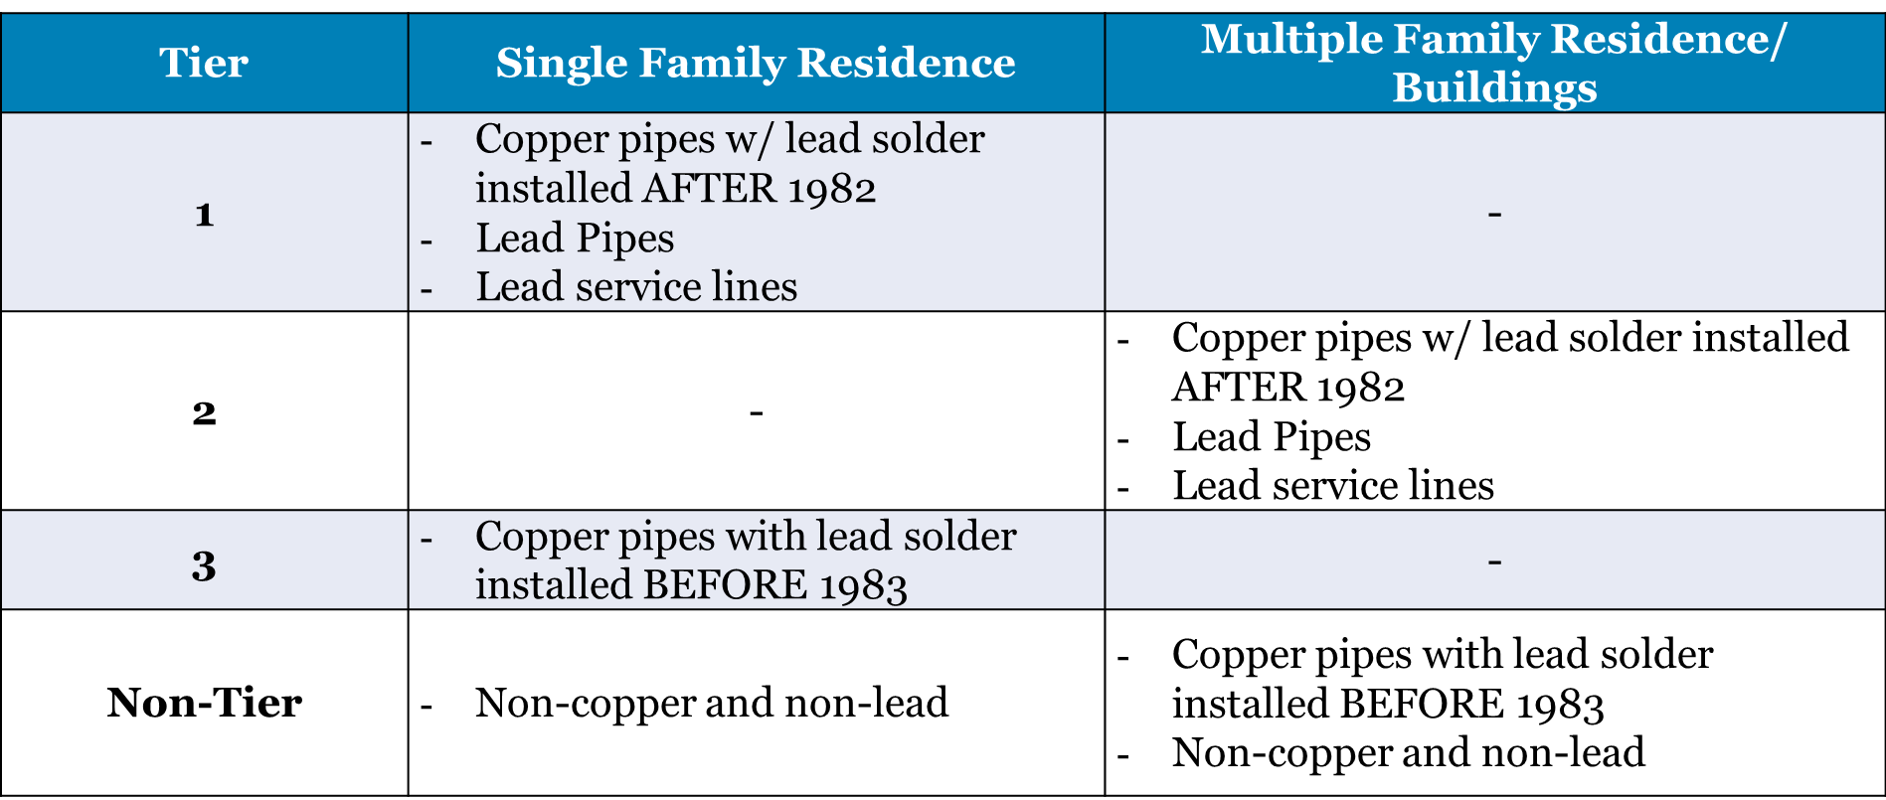

## Sampling Procedure Guidance for Homeowners

Do not sample from vacant homes or from outside spigots. On February 29, 2016 EPA released updated instructions on sampling.

* Sampling Procedure Guidance for Homeowners
* Sampling Procedure Guidance for Homeowners (Spanish)

Systems are required to notify the residents of the sample results from their home. You can use the attached template to notify the homeowners. You must certify to the state that you have distributed the notices by filling out the online or PDF version of the Consumer Notification Certification Form.

* Consumer Notice Template of Lead and Copper Sample Results: PDF and DOC
* Consumer Notice Certification Form: Online
* Consumer Notice Certification Form: PDF

## Calculating Compliance

Sample results are evaluated against an action level. The lead action level is exceeded if the concentration in more than 10% of samples is greater than 0.015 mg/L (i.e. the 90th percentile lead level is greater than 0.015 mg/L). The copper action level is exceeded if the concentration in more than 10% of samples is greater than 1.3 mg/L (i.e. the 90th percentile copper level is greater than 1.3 mg/L).

* Summary Sheet and 90th Percentile Calculator (excel)

If your lead or copper 90th percentile result exceeds the action level, contact the Division immediately.

## Action Level Exceedance

If there is a lead or copper action level exceedance, the water system will be moved back their initial monitoring count and will be sampling for lead and copper every six months.

The system will need to conduct water quality parameter monitoring and source water monitoring. The system will be expected to prepare a Corrosion Control Treatment Recommendation to the Division and release public education.

* ALE Public Education Requirements
* EPA Guidance on Corrosion Control Treatment Recommendation

If the system completes two rounds of initial monitoring with 90th percentile results below the action level, they can stop the corrosion control process.

## Additional Resources

* Lead Sampling in Schools
* 90th Percentile Values for all Utah Water Systems (Jan 2017)
* Lead Frequently Asked Questions (FAQ’s)
* Lead and Copper: A Quick Reference Guide